BOOK BANK REGISTERATION SYSTEM

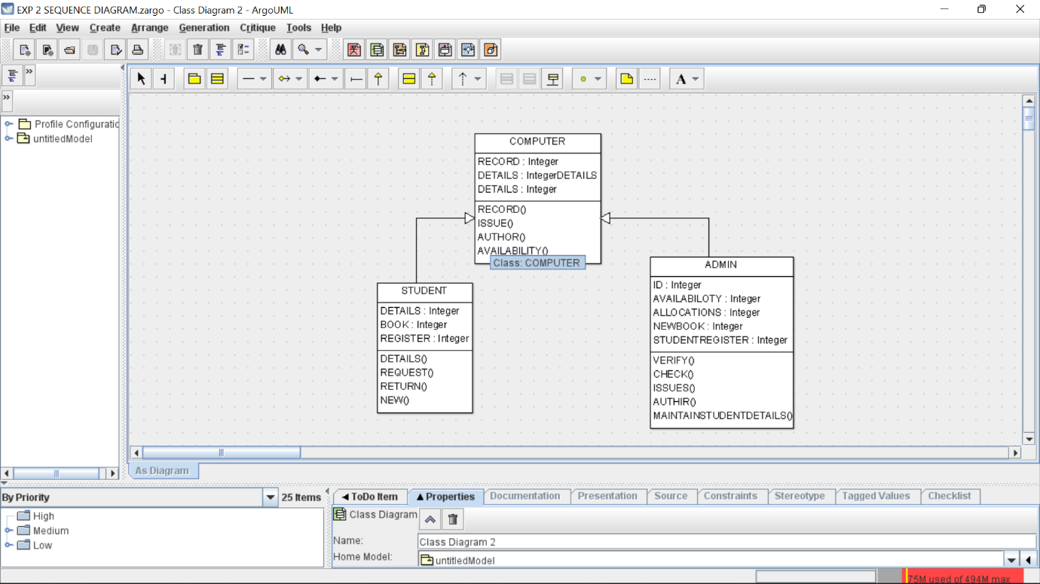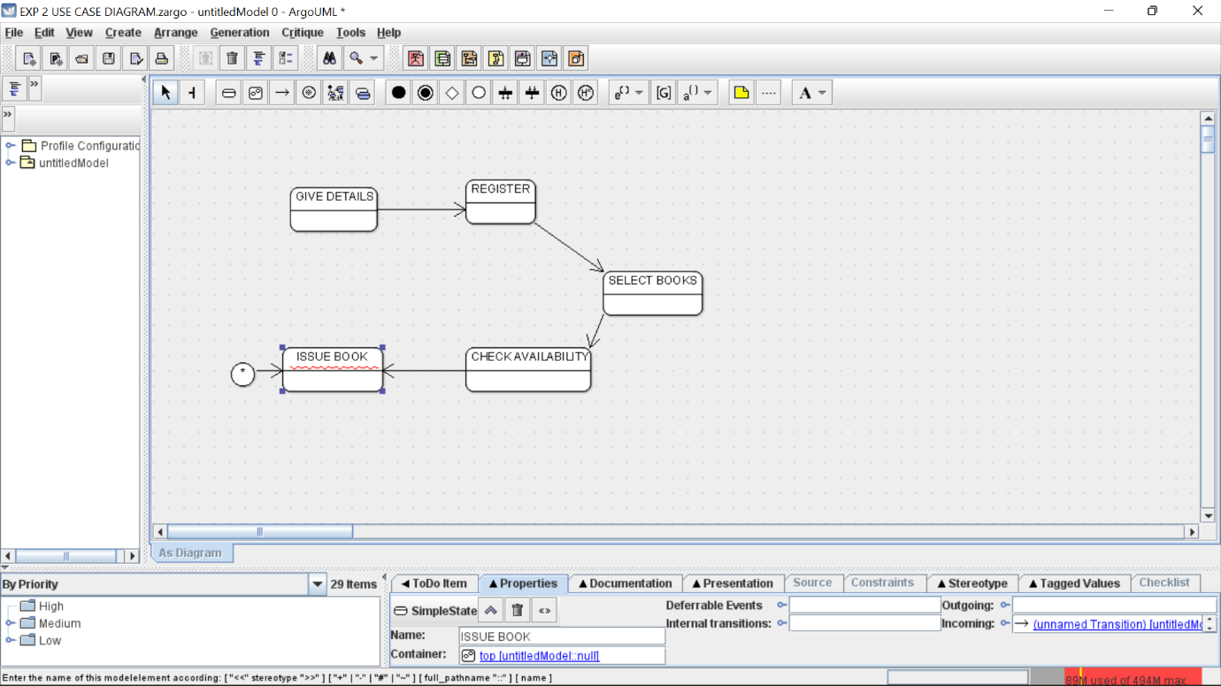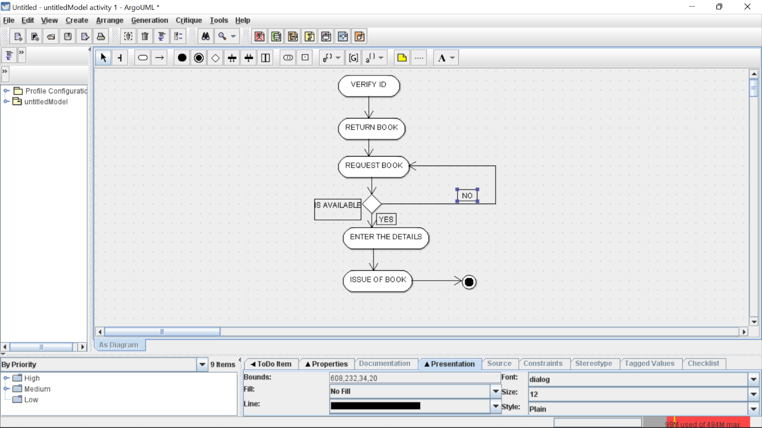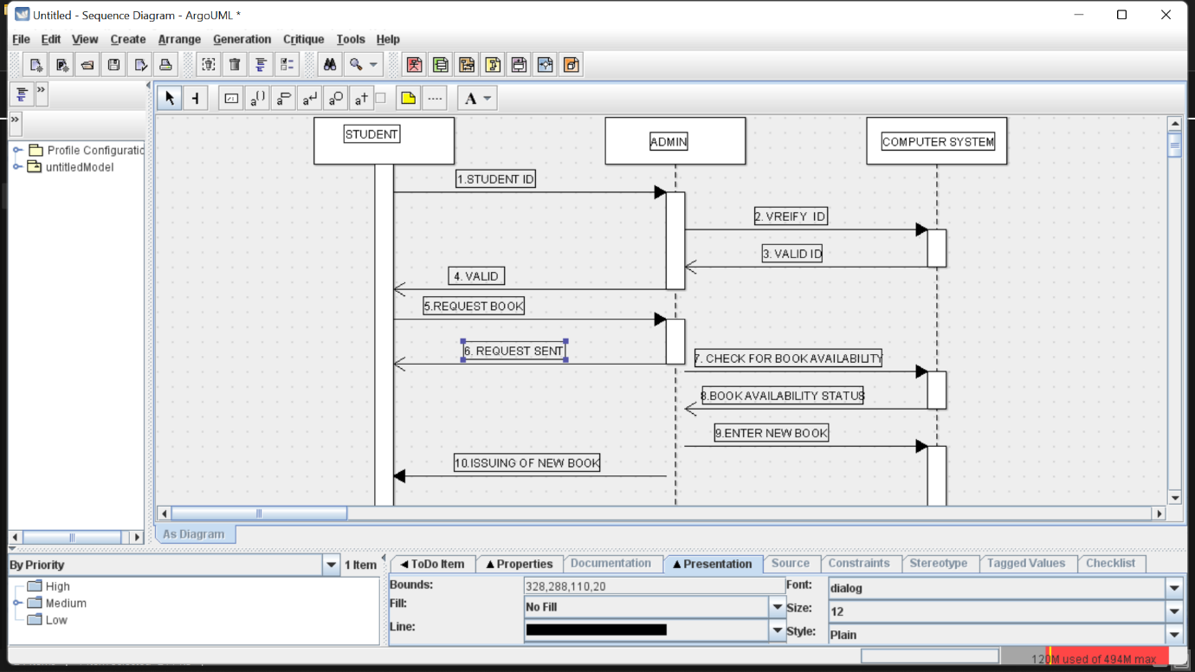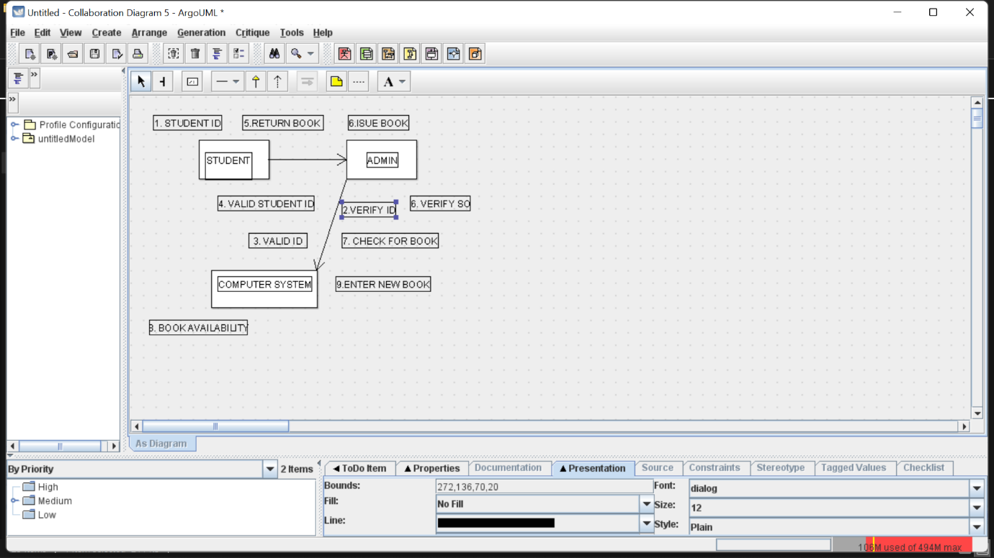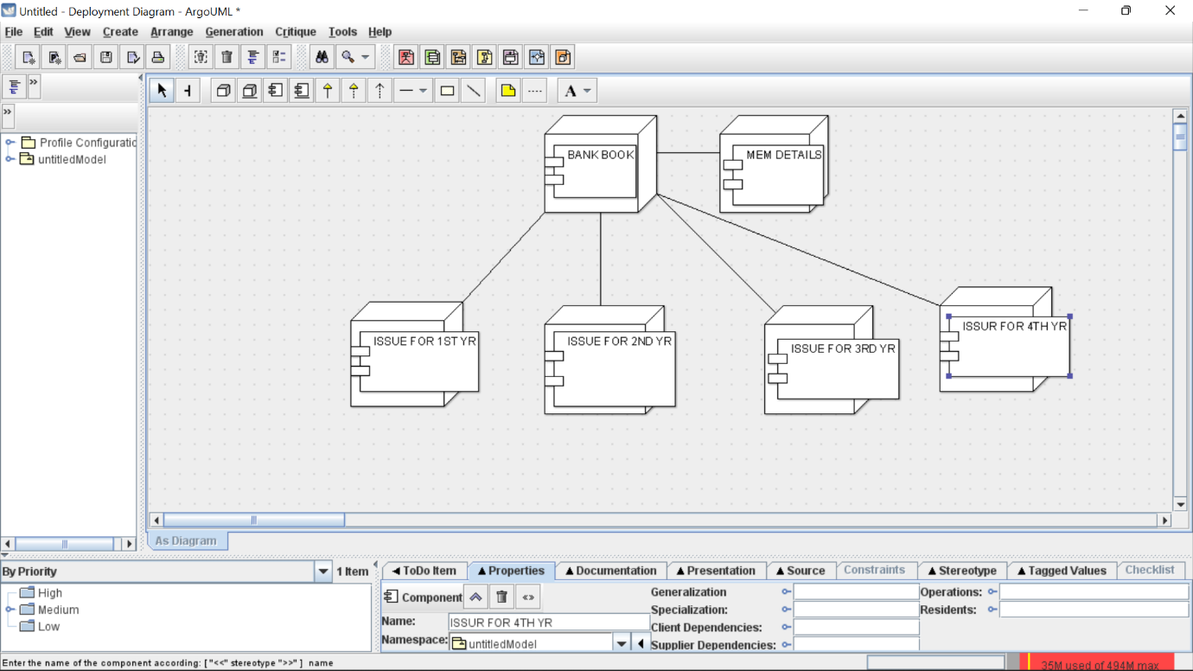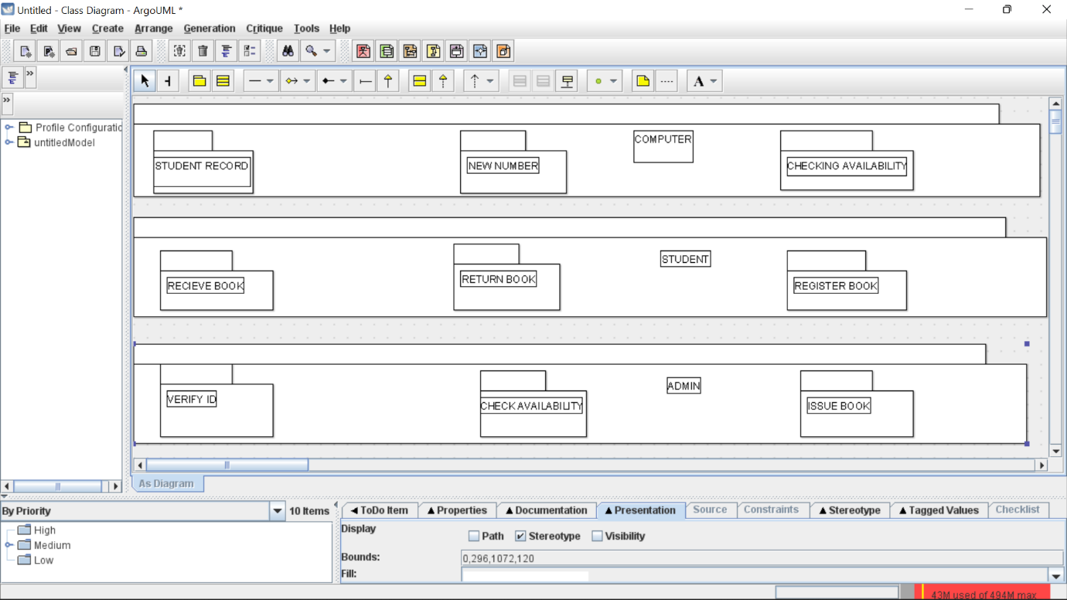

SKELETON CODE

public class ADMIN extends COMPUTER {

private Integer ID;

public Integer AVAILABILOTY;

public Integer ALLOCATIONS;

public Integer NEWBOOK;

public Integer STUDENTREGISTER;

public void VERIFY() {

}

public void CHECK() {

}

public void ISSUES() {

}

public void AUTHIR() {

}

public void MAINTAINSTUDENTDETAILS() {

}

}

public class COMPUTER {

private Integer RECORD;

public IntegerDETAILS DETAILS;

public Integer DETAILS;

private void RECORD() {

}

private void ISSUE() {

}

private void AUTHOR() {

}

public void AVAILABILITY() {

}

}

public class STUDENT extends COMPUTER {

private Integer DETAILS;

private Integer BOOK;

public Integer REGISTER;

private void DETAILS() {

}

private void REQUEST() {

}

private void RETURN() {

}

private void NEW() {

}

}